Project Plan

Software Deployment

Josh Macaulay 30008704

2020

Table of Contents

Project Details 1

Required Application 1

Success Criteria 1

Project Management Software 1

Development Methodology 1

Source Control 1

Project Software 1

Collaboration Software 1

Project Initiation 2

The First Phase 2

The Goal 2

Project Planning 3

Development Plan 3

Project Monitoring 4

Collaboration – Trello 4

# Project Details

## Required Application

The required finished project is a program that reads in movie titles from a database, that the user can enter a search term and it will list any matches of the term with movies from the database.

## Success Criteria

The product will be completed when all functionality is implemented, is error free, is packaged in installation software, and is deployed to our target (the client).

## Project Management Software

### Development Methodology

For this project we will be using the Waterfall approach, as this is a smaller project that we can elicit all the necessary requirements easily. Other methodologies are useful when the project becomes larger and if the development environment has frequent requirement changes or additions, however these requirements are rigid, and a simple Waterfall methodology will work.

### Source Control

The application will be developed using GitHub as its source control system. This system allows collaboration and easy version management as well as rollbacks to previous versions if some error causes a malfunction.

<https://github.com/JMac118/Software-Deployment-Project>

### Project Software

Project Libre will be used as it is a free-to-use software that can produce Gantt charts from a task list as well as resource management.

### Collaboration Software

For this project we are using Trello as our collaboration software. This allows us to add tasks to a list, and track which developer is working on each task. It also keeps track of completed tasks and ones still on the to-do list.

<https://trello.com/b/9he5fsKf/dvd-search-app>

# Project Initiation

## The First Phase

Development of the application will begin when our source control repository on GitHub is created. The base java application files will be added, libraries set-up for SQL, database set-up and filled, and connection established through the java program.

## The Goal

The overall goal of the project is to ship a program to our client that satisfies the requirements of searching a movie database to list titles associated with a search term.

# Project Planning

## Development Plan

The tasks will be allocated and completed one at a time until the project is finished. Starting from setting up the development environment, we will implement the connection between the database and the java application, then create a user interface to display and search, and finally to implement the query system to retrieve data from the database and send it to the UI for displaying. The tasks are outlined in the Gantt chart below.

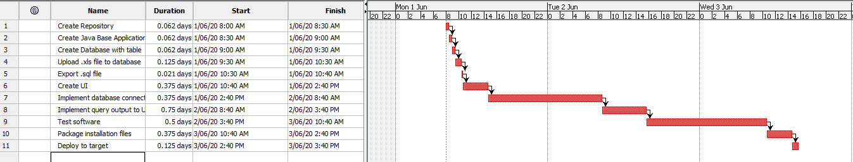

This Gantt chart was created in Project Libre.

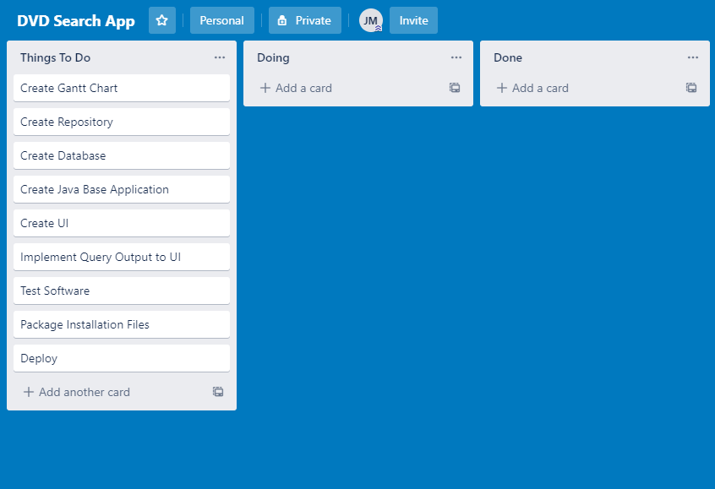

This to-do list was made in Trello

# Project Monitoring

## Collaboration – Trello

These Trello screenshots are environment captures of the project during development.



